Cybersecurity in 2025: Protecting Your Digital Future
Cybersecurity in 2025 has reached a critical turning point as digital systems become deeply integrated into everyday life. With the rapid advancement of AI, both attackers and defenders now rely on intelligent technologies, making cyber threats more sophisticated than ever before. Hackers are using generative AI to craft realistic phishing scams, deepfake frauds, and automated malware that can bypass traditional security tools. At the same time, organizations are adopting advanced defense systems that detect anomalies, predict attacks, and respond instantly without waiting for human intervention. The shift toward remote work, cloud platforms, and interconnected devices has expanded the attack surface, forcing businesses to implement Zero Trust models and stronger data protection policies. Pass wordless authentication, biometrics, and hardware tokens are becoming mainstream as companies work to reduce identity theft. With increasing regulations and rising ransomware incidents, cybersecurity in 2025 is no longer just a technical requirement it has become a strategic necessity for business continuity, trust, and long-term growth
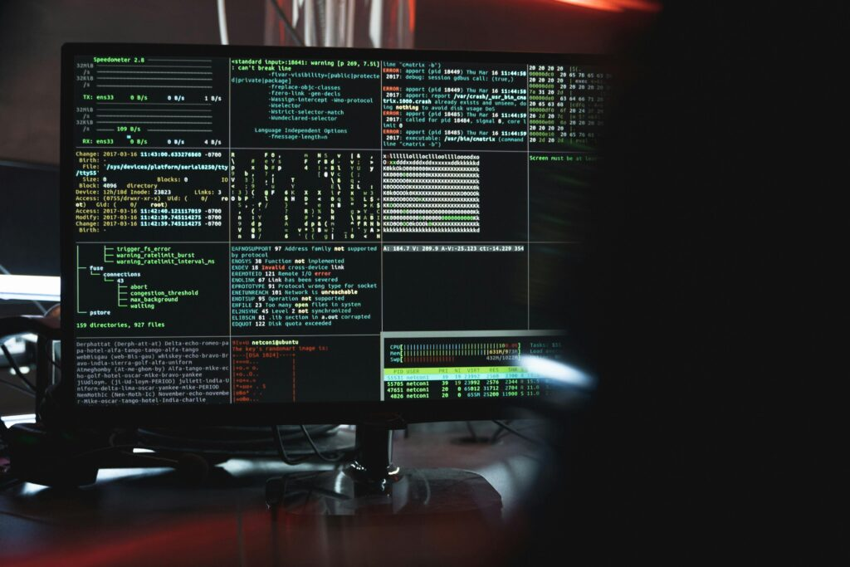
Cybersecurity in 2025 is all about staying ahead of fast-evolving digital threats and protecting your data in an increasingly connected world. As AI-powered attacks grow smarter and more automated, individuals and businesses must adopt stronger, more proactive security strategies. Cybercriminals now use deepfakes, AI-generated phishing messages, and ransomware-as-a-service platforms, making online risks more unpredictable. To safeguard digital identities, modern security standards like Zero Trust, multi-factor authentication, and pass wordless logins are becoming essential. The rise of cloud computing, remote work, and smart devices has expanded the areas hackers can target, pushing companies to invest heavily in advanced threat detection systems. In 2025, protecting your digital future means being aware, staying updated, and using the right security tools to build resilience in a world where cyber threats never stop evolving.
The Rise of AI-Driven Cyber Threats
In 2025, cybercriminals are using artificial intelligence to launch faster, smarter, and more targeted attacks. AI-generated phishing emails look completely real, deepfake videos are used to trick employees, and automated bots can break into unsecured systems within seconds. This new wave of AI-enabled attacks is pushing organizations to strengthen their security like never before.
Zero Trust Becomes the New Standard
Traditional cybersecurity models that relied on firewalls and passwords are no longer enough. In 2025, the Zero Trust approach—“never trust, always verify”—has become the backbone of digital security. Every device, user, and network request must be verified continuously. This reduces the chances of unauthorized access and helps businesses stay protected even if one layer is compromised.
Pass wordless Authentication Is Mainstream
Passwords are becoming outdated, and 2025 marks the shift toward pass wordless security. Biometrics like fingerprint scans, facial recognition, and hardware security keys are now widely used. This reduces identity theft and helps individuals protect their online accounts more effectively.
Cloud Security Takes Center Stage
As more companies move to cloud platforms for storage and operations, cloud security has become a top priority. Organizations must secure every part of their cloud environment—from access controls to data encryption—to avoid breaches. Cloud-based security tools now monitor behavior in real time and stop attacks before they spread.
Ransomware Continues to Be a Major Threat
Ransomware attacks in 2025 are more dangerous and expensive. Cybercriminals not only encrypt data but also threaten to leak it if the ransom is not paid. Small and medium-sized businesses are especially at risk because they often lack advanced defenses. This makes regular backups, strong network protection, and employee training more important than ever.
The Importance of Cyber Awareness
Technology alone cannot keep you safe—your behavior matters too. In 2025, organizations are investing heavily in cybersecurity training to help employees recognize suspicious links, avoid fake messages, and report unusual activities quickly. A well-trained team is still one of the strongest lines of defense.
Government Regulations and Compliance
Governments worldwide are enforcing strict data protection laws, requiring companies to take cybersecurity seriously. Businesses must follow guidelines for data privacy, breach reporting, and customer protection. Staying compliant not only avoids fines but also builds trust among customers.
Protecting Your Personal Digital Life
Cybersecurity in 2025 is not just for businesses—individuals must also protect their digital identities. Using strong authentication methods, enabling device encryption, avoiding risky apps, and keeping software updated are essential habits. As smart homes and IoT devices grow, protecting your Wi-Fi network is equally important.
The Future of Cybersecurity Careers
With cyber threats increasing, the demand for cybersecurity professionals is higher than ever before. Roles like ethical hackers, SOC analysts, threat hunters, and cybersecurity engineers are becoming some of the most in-demand jobs in technology.

Conclusion
Cybersecurity in 2025 is no longer just a technical necessity—it has become a critical foundation for both personal safety and business success. As AI-driven threats grow more advanced and digital systems expand across every part of our lives, protecting data requires a proactive, smart, and continuous approach. By adopting modern security practices like Zero Trust, pass wordless authentication, cloud protection, and regular cyber awareness training, individuals and organizations can stay resilient in a rapidly evolving digital world. The future belongs to those who prepare, stay informed, and prioritize cybersecurity as a long-term investment. Protecting your digital future starts today.

